Setup for Facebook Messenger Bot.

1. Go to <https://developers.facebook.com> and login with your facebook email and password.
2. Click on My apps and click on Add New App

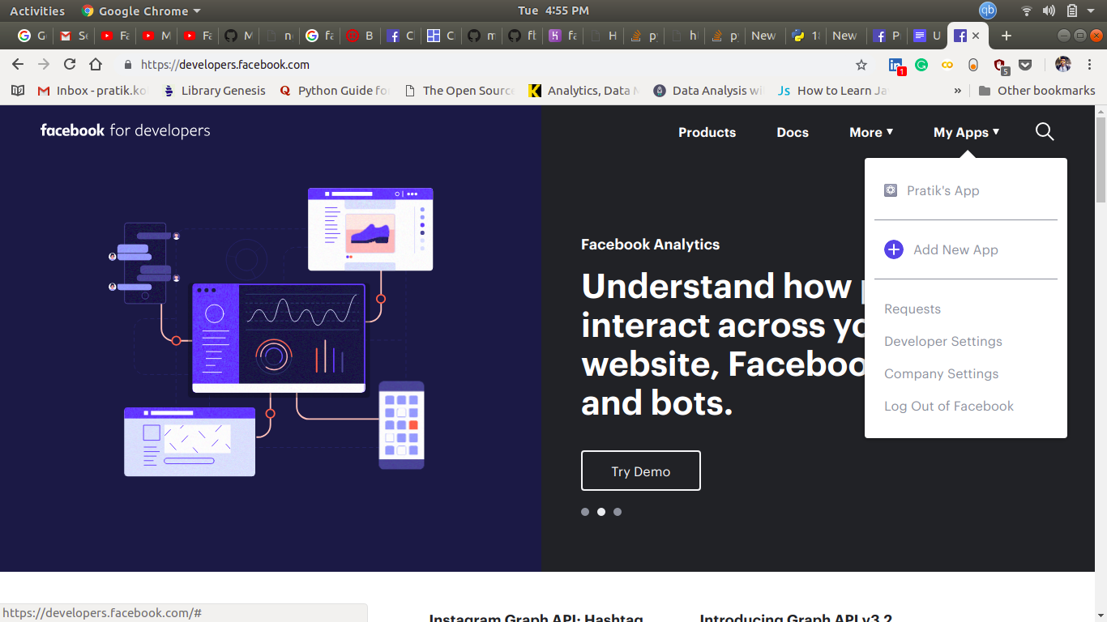

1. Enter a display name for your app.

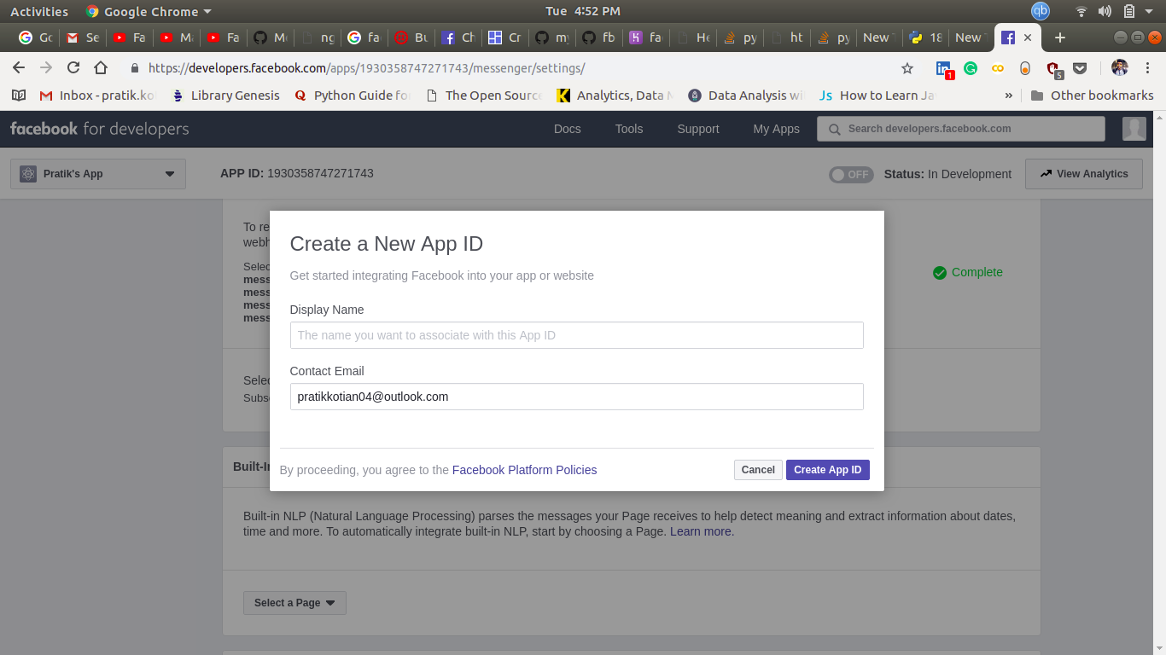

4.Once it is done , select messenger setup.

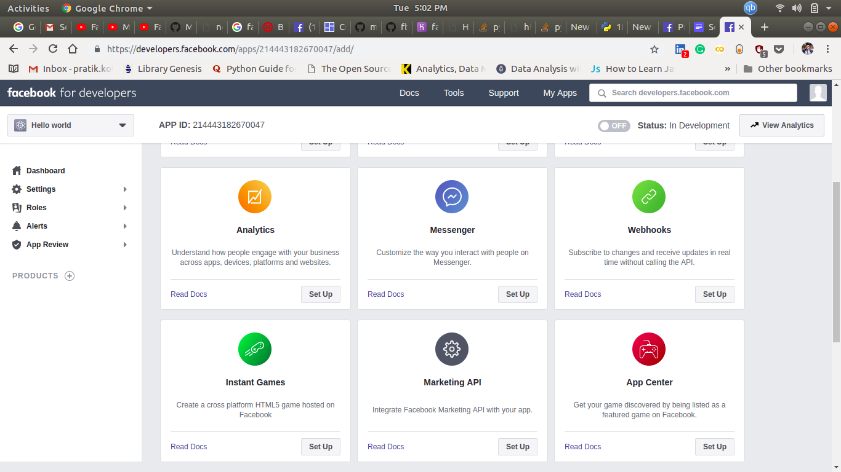

5.After redirecting to next page,scroll down to **Token Generation** and select the page to which you want your messenger bot to be deployed.

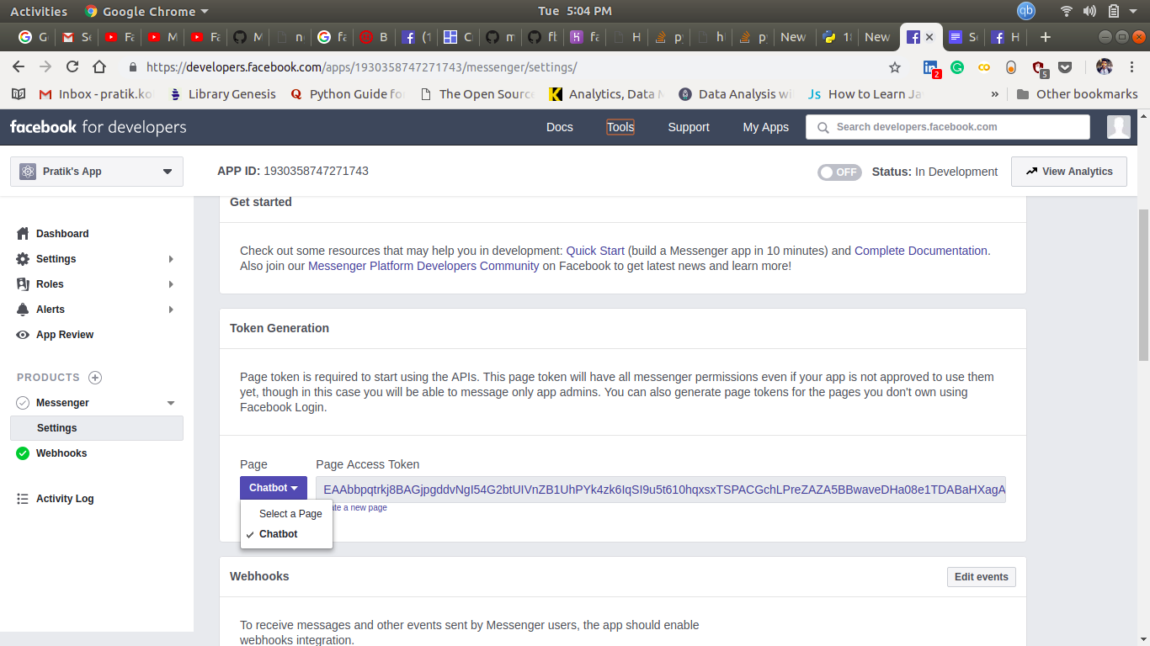

6.Once it’s done the next step is to ,setup a webhook so that we can receive and send messages through facebook messenger.

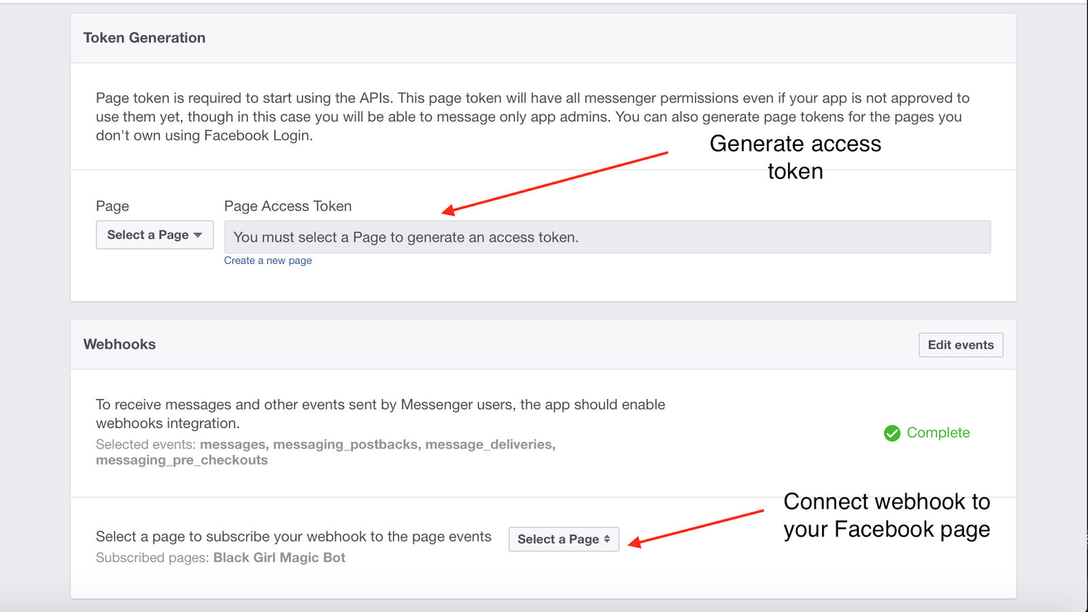

7.Once you do that a pop-up window will be opened where we have to fill the **Callback URL** i.e the server address where our code is deployed and a **Verify Token** which we can use to authenticate out bot.And select all the **Subscription Fields**.

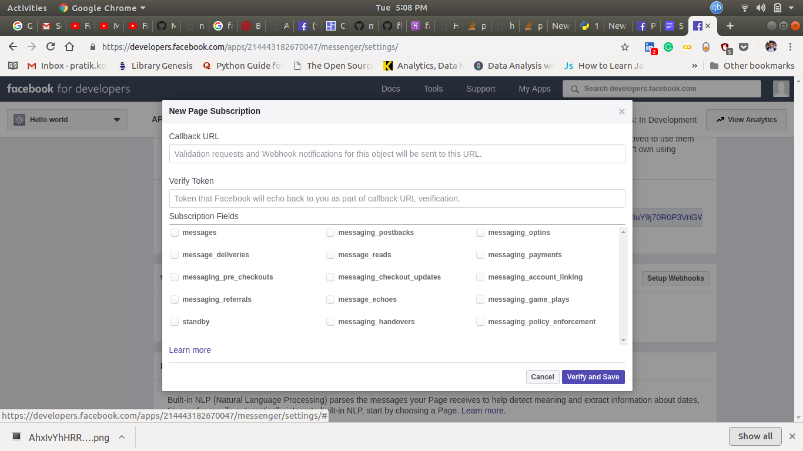

8.Once you feel that the app is ready to be live for general audience you can submit it for review after doing following things:  
a. check several boxes verifying that you’ve read their policies and guidelines  
b. promise you won’t engage in unsolicited, outbound messaging.  
c. agreeing that you have a privacy policy.  
d. upload a screen-shot of you interacting with your bot.

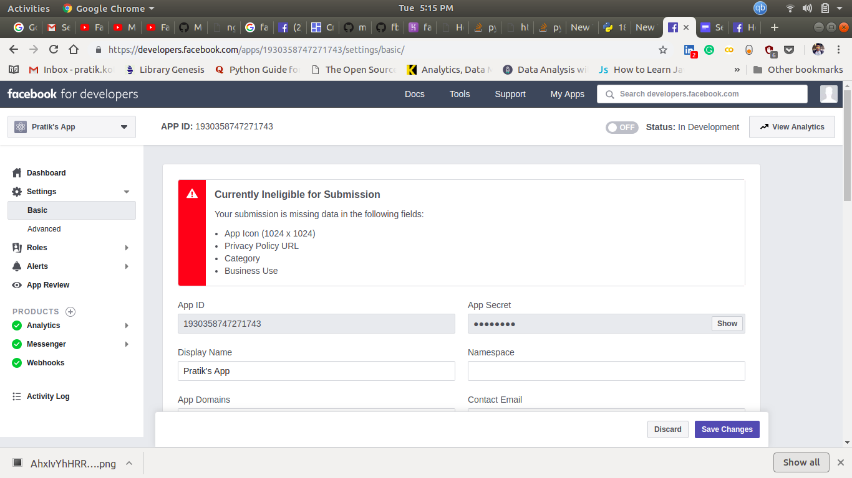

Full process can be read here :- <https://developers.facebook.com/docs/messenger-platform/app-review>